**Question No. 3**

For the given initial value problem

$$\frac{dy}{dx}=x^{3}+ y , y(0) = 1$$

a. Write the MATLAB function to solve numerically using Runge Kutta fourth order method.

b. Find the exact solution using MATLABs built-in function `***dsolve*'**.

c. Plot the exact and numerical solution in the interval [0,1] choosing step size h=0.1 in the same figure.

**Solution:**

function [] = runge_kutta( f,yo,xo,h,xn )

x= xo:h:xn;

n = length(x);

y = zeros(1,n);

y(1) = yo;

for i = 2:n

k1 = h*f(x(i-1),y(i-1));

k2 = h*f(x(i-1)+h/2,y(i-1)+k1/2);

k3 = h*f(x(i-1)+h/2,y(i-1)+k2/2);

k4 = h*f(x(i-1)+h,y(i-1)+k3);

y(i) = y(i-1) + 1/6*(k1+2*k2+2*k3+k4);

end

z = eval(dsolve('Dy=x^3+y','y(0)=1','x'));

fprintf("numerical solution: ");

disp(y)

fprintf("exact solution: ");

disp(z);

plot(x,y,'r',x,z,'k*')

end

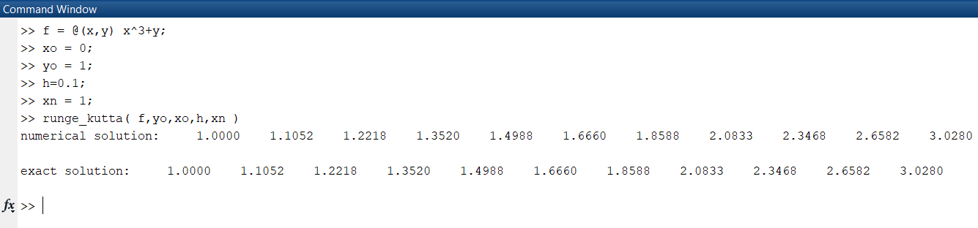

Figure 1 assigning values and calling function in command window



Figure 2 Graph output